NADI MUSLIM COLLEGE

ACHIEVEMENTS AND HIGHLIGHTS 2025

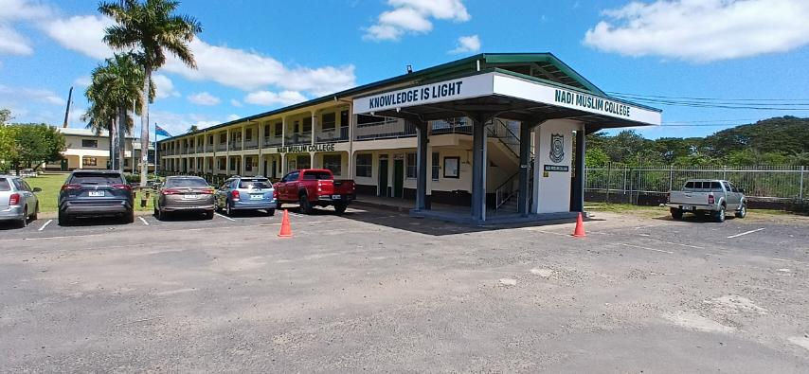

SCHOOL ROLL
TOTAL – 970 (MALE – 448) (FEMALE – 522)

STAFF – 54 – Civil Servants
2 – Committee Paid
5 – Anciallary Staff

ACHIEVEMENTS
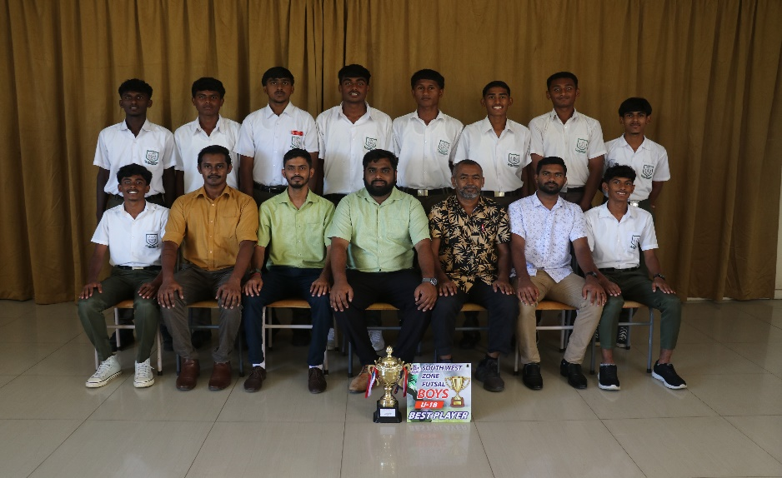
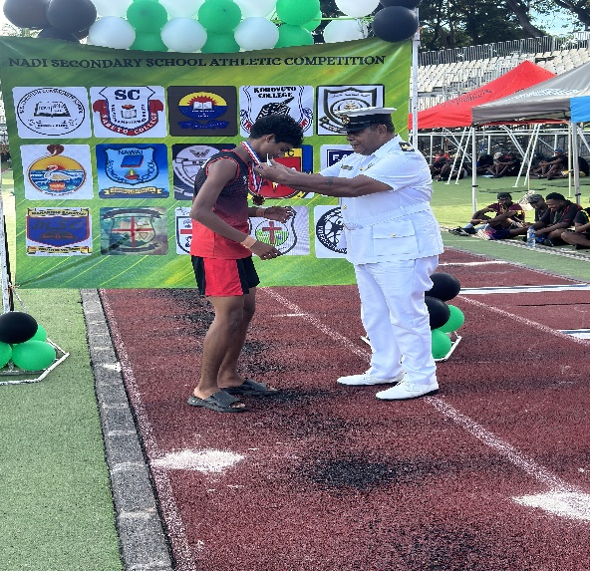
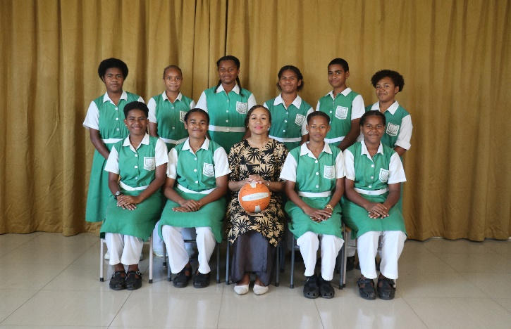
BEST MALE ATHLETE CHAMPIONS FOR SOUTH WEST FUTSAL
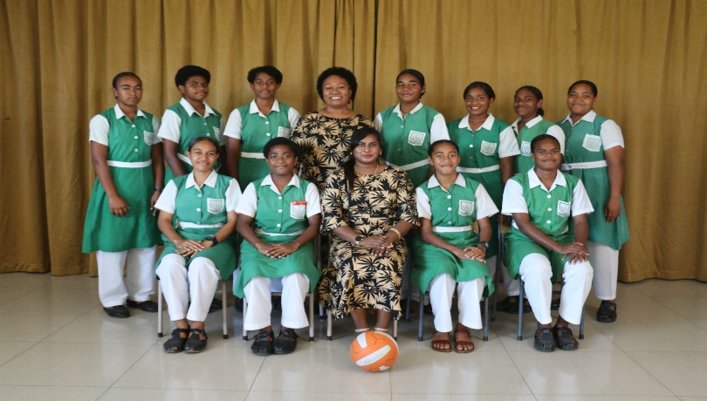

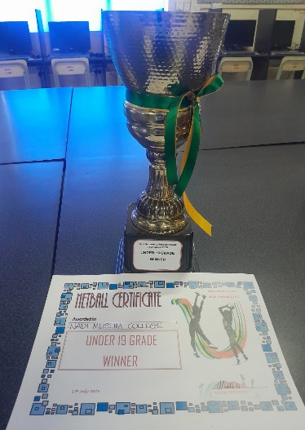
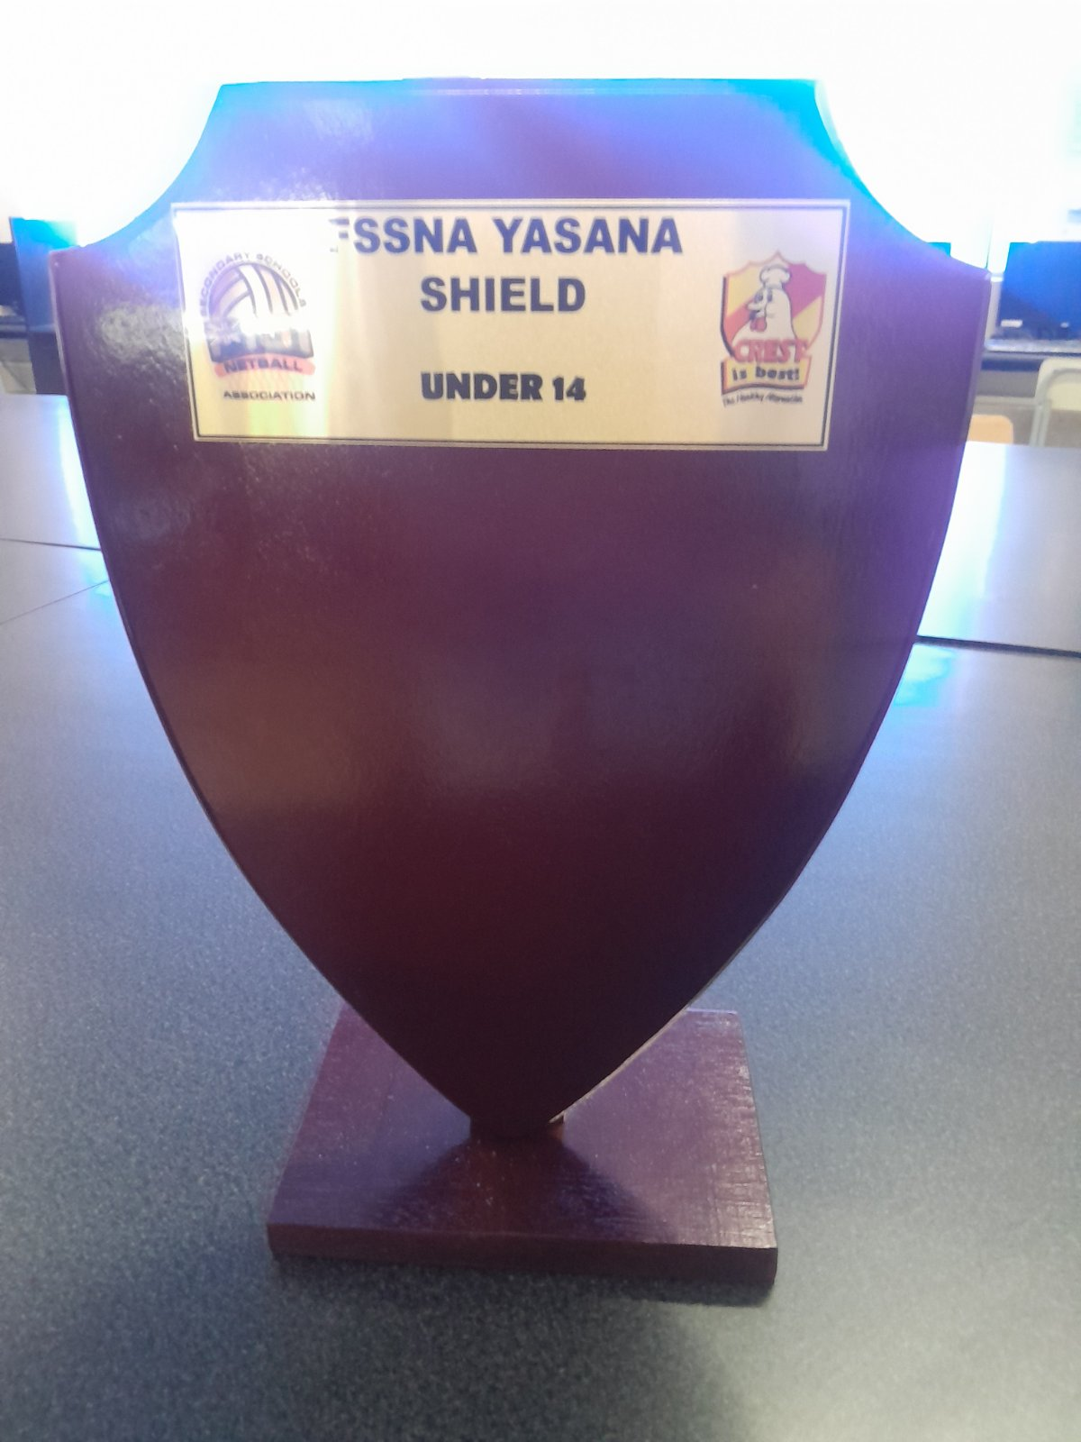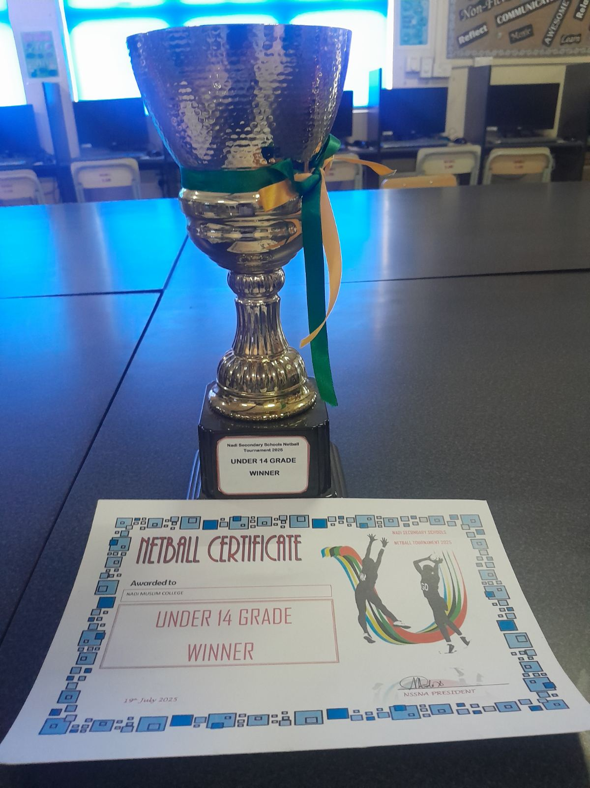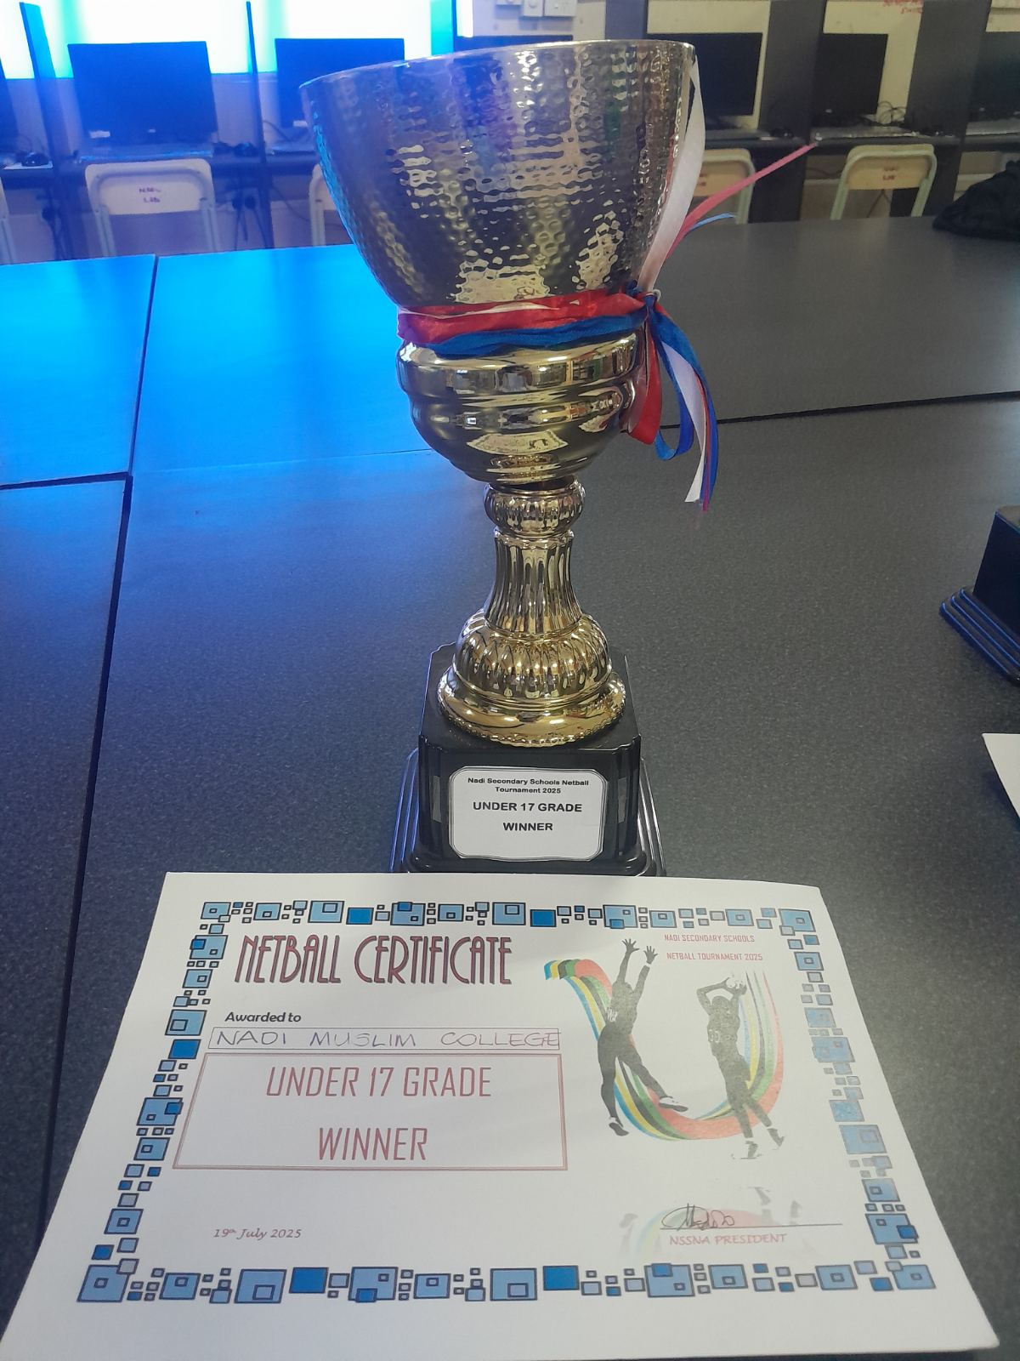
NETBALL DISTRICT/FINAL CHAMPIONS


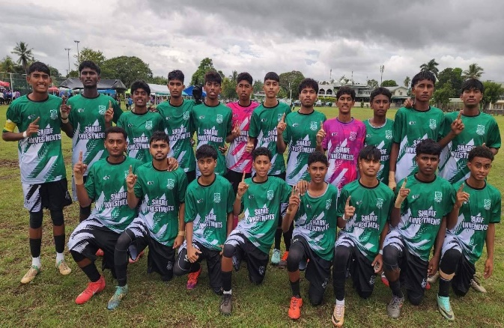
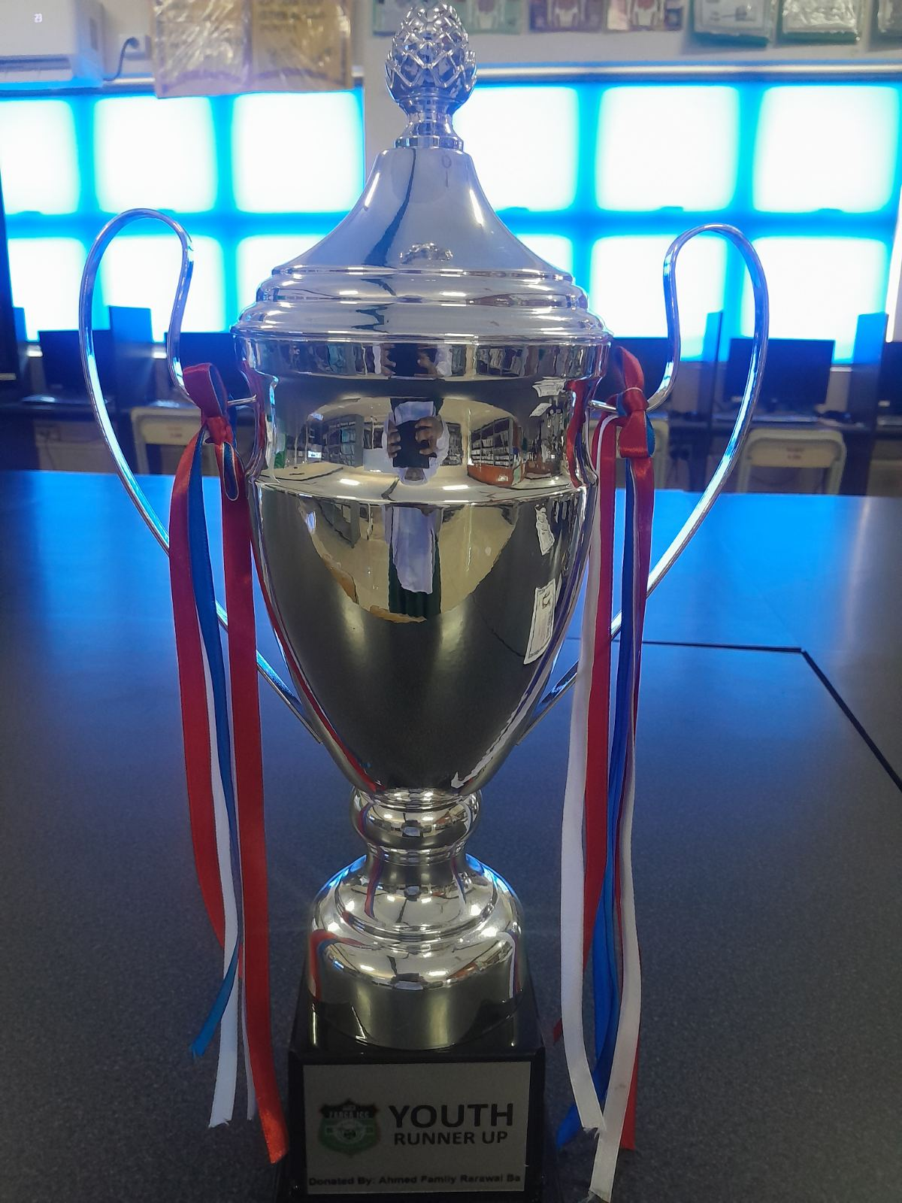
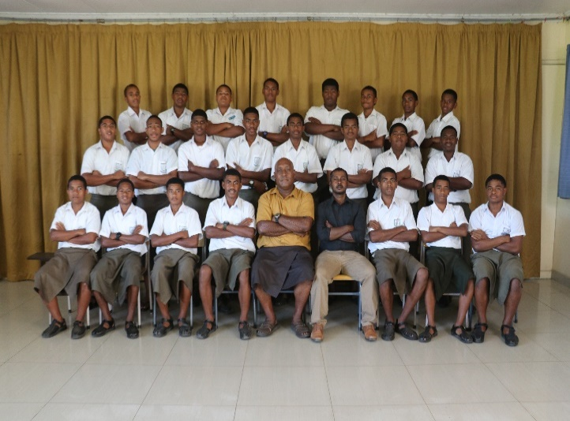
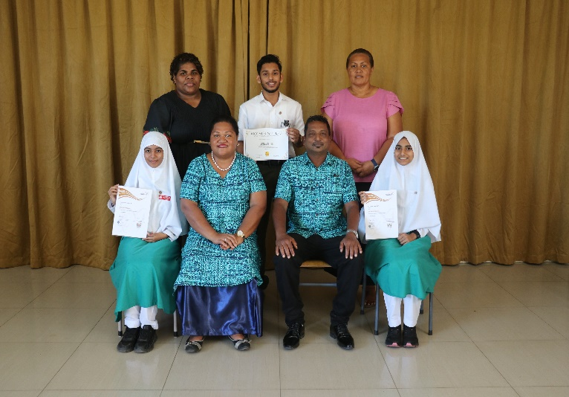
FIJI MUSLIM IDC CHAMPIONS

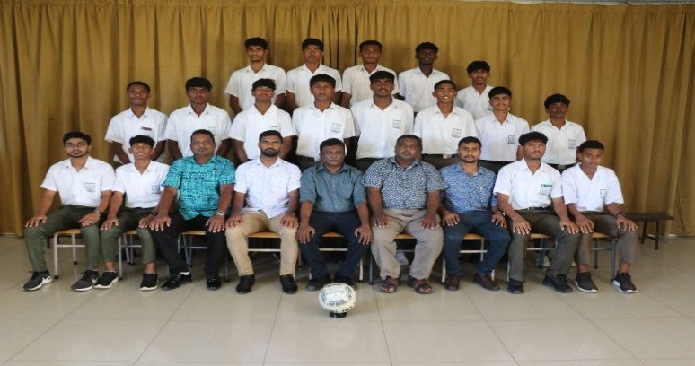
DUKE OF EDINGBURGH ACHIEVEMENTS RUGBY U15 WESTERN QUARTER FINALIST

SOCCER U19 DISTRICT RUNNER-UP

UPCOMING SCHOOL HALL PROJECT
