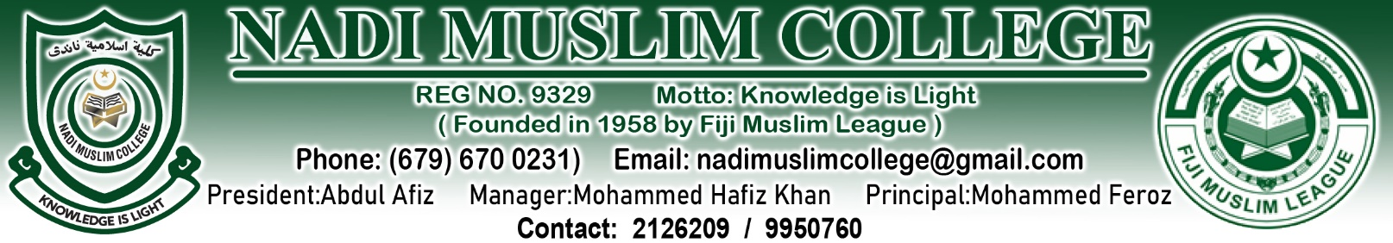
30th January, 2026
Nadi Muslim College Newsletter – Academic Year 2026
Assalamu Alaikum Wa Rahmatullahi Wa Barakatuhu,
Bula Vinaka and Warm Greetings to All,
On behalf of the Management, Staff, and Board of Governors of Nadi Muslim College, I warmly welcome all our students, parents, and teachers to the 2026 Academic Year. We thank Almighty Allah for granting us the opportunity to begin another year of learning, growth, and service.
A very special and heartfelt welcome to our new Year 9 students and their families. We trust that you will quickly settle into the proud culture, values, and high academic expectations of Nadi Muslim College. You are now part of a learning community that strives for excellence in academics, character, discipline, and Islamic values.
Outstanding Academic Achievements – 2025 Results
We are extremely proud to share our excellent academic outcomes:
- Year 13 Pass Rate: 98%
- Year 12 Pass Rate: 76%
These results reflect the hard work, dedication, and resilience of our students, the commitment of our teachers, and the strong support provided by parents and guardians.
Congratulations to all parents and students for this outstanding achievement. Together, we continue to raise the standards of academic excellence at Nadi Muslim College.
Staffing Update
We are pleased to inform our school community that all staffing positions are now intact, and we have successfully received all necessary replacements. This ensures continuity in teaching and learning, and stability for our students.
We sincerely thank:
- The Ministry of Education – Nadi Branch, and
- The Fiji Muslim League (FML)
for their continued support and cooperation in strengthening our staffing and operational capacity.
Enrollment Status
Please note that student enrollment for 2026 is now nearing closure. Parents who have not yet finalized outstanding enrollment matters are urged to do so immediately. Late enrollment may not be accommodated once classes are fully settled.
Repeat Policy – Important for All Parents
Parents are strongly advised to familiarize themselves with the College’s Repeat Policy, which is now fully in effect.
This policy is designed to ensure that students are placed at the appropriate academic level to support their success and long-term progression. Decisions regarding repeating a year are made based on academic performance, attendance, and overall readiness.
We urge parents to work closely with the school to understand how this policy operates and how it may apply to their child.
Student Grooming & Uniform Expectations
The College places high importance on student presentation, discipline, and grooming, as these are essential aspects of our school culture.
Parents are responsible to ensure that all students report to school:
- With neat, school-approved haircuts
- Well-groomed appearance
- Wearing proper black school shoes

📌 Important Notice:
From Monday, the school will begin contacting parents directly if a student is still not properly groomed or does not meet uniform and haircut standards.
All students must have a proper school haircut (school cut). This is not optional and is part of maintaining discipline, safety, and a professional learning environment.
School Annual General Meeting (AGM) – Important Notice to All Parents
All parents and guardians are hereby informed that the Nadi Muslim College Annual General Meeting (AGM) will be held as follows:
Date: Friday, 13th February 2026
Time: 1:30 pm
Venue: NMC Events & Sports Centre
All parents are strongly encouraged to attend, as important matters regarding school operations, academic progress, policies, and future development projects will be discussed.
Your presence and participation are vital in strengthening the partnership between parents and the school. We look forward to your valued support and contribution.
Working Together for Student Success
At Nadi Muslim College, we believe that student success is built on a strong partnership between school and home. We kindly ask all parents to:
- Monitor attendance and punctuality
- Support homework and study routines
- Reinforce discipline and school values
- Communicate with teachers and school management when needed
Together, we can ensure that 2026 is a year of strong academic performance, good character development, and continued growth for every child.

We thank you for your continued trust, cooperation, and support of Nadi Muslim College.
May Allah grant success to all our students and bless our teachers, parents, and school community for a productive and rewarding year ahead.
Yours sincerely,
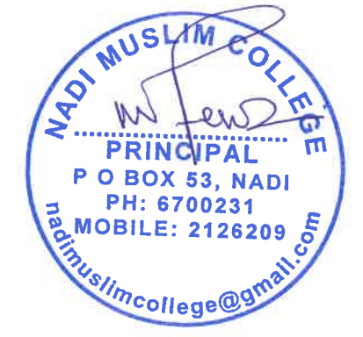
Mr. Mohammed Feroz
Principal

